2. ReactJS-HOL

1) Successful Creation of the React Project (studentapp)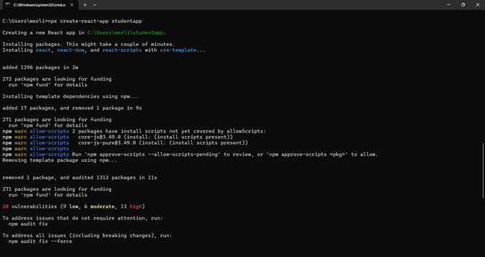

2: React Project Opened in Visual Studio Code
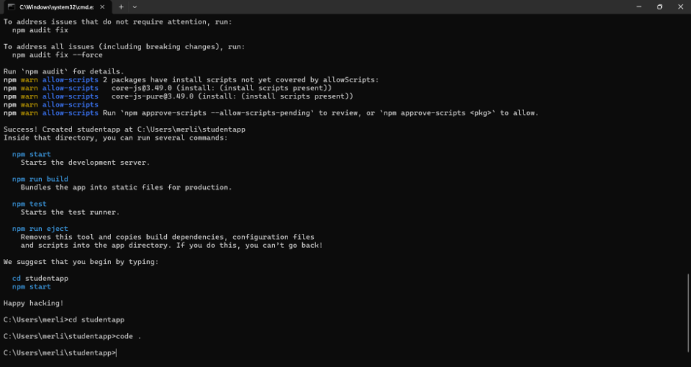

3: Successful Compilation and Execution of the React Application
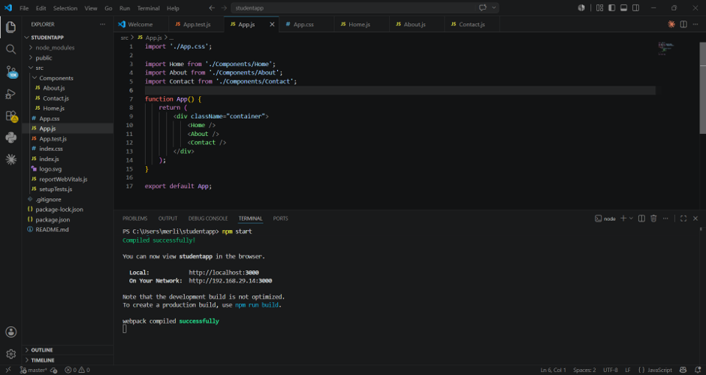

4: Output of the Student Management Portal
